Flight analytic project
Source of data: https://rapidapi.com/aedbx-aedbx/api/aerodatabox
Approach for importing the data: The data is fetched from the aerodatabox API's by creating accounts and subscribing for testing.
As we had subscribed to free testing there is a limitation of 300 api calls/month. Hence, the data was stored in local csv files and then after formatting the data in required format it was inserted in the MySQL database tables.
API --> .csv file --> DB

The data imported into the DB in the following order
1. Airport: file - Flight-Analytics\Code\Aircraft.ipynb
- Got airport IATA data online for 15 airports(domestic and international)
- Fetched data from API - https://aerodatabox.p.rapidapi.com/airports/iata/ for each airport and stored it in AircraftsData.csv
- Moved the data into FlightDB.Aircrafts table.
2. Flight: file - Flight-Analytics\Code\Flights.ipynb
- Fetched data from API - https://aerodatabox.p.rapidapi.com/flights/airports/iata/ for each selected airport. Since the API allowed only 2 days of data at a time it had to be executed 3 times for each airport for 6 days of data
- As the data was huge it was stored in multiple csv files and the data merged.
- Data for filtered for origin and detination to be from selected 15 airports.
- Stored data in FlightDB.Flights table after formatting the data for required fields.
3. Aircraft: file - Flight-Analytics\Code\Aircraft.ipynb
- Get aircraft information from flight data in csv file.
- Fetched aircraft details from API - https://aerodatabox.p.rapidapi.com/aircrafts/reg/
note: I could not get all aircraft details from the API
- Store the data in FlightDB.Aircrafts table after formatting the data for required fields.

4. Airport flight delay: file - Flight-Analytics\Code\FlightDelay.ipynb
- The API provided details for all flights from a airport, as we are rescricting our analysis for the selected 15 airports. I did not use the API data
Instead, I calculated the delay information from the panda's functions from the flight data in csv file.
- Store the data in DlightDB.FlightDelays table.

Database schema:
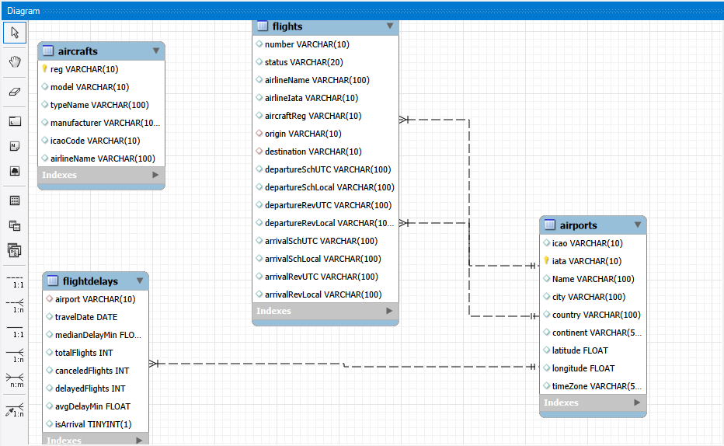

Streamlit App: file - Flight-Analytics\Code\UI.py
- Landing page
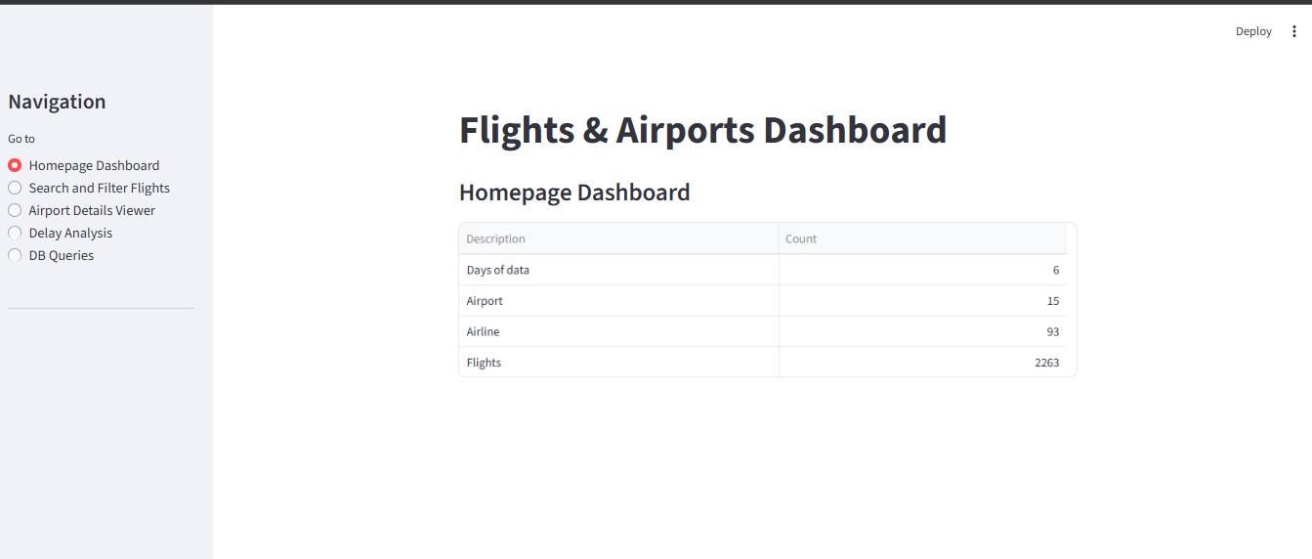

- Flight search page, We can search flight by origin, destination and date
The page displays flight information and selected flight aircraft details
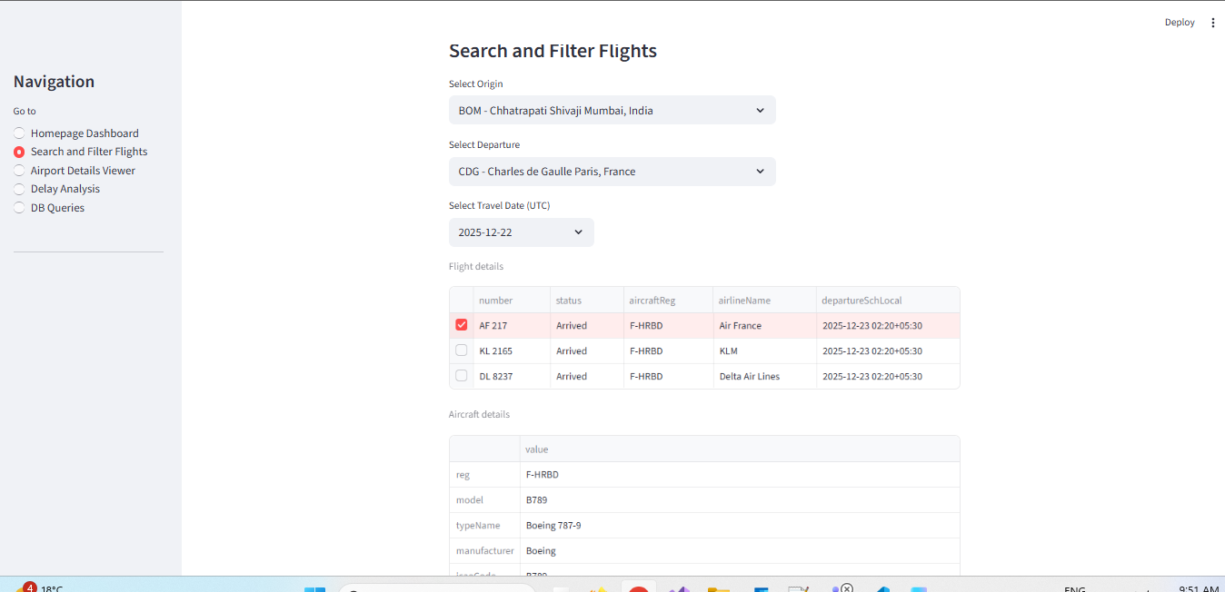

- Airport search page, it displays airport details.
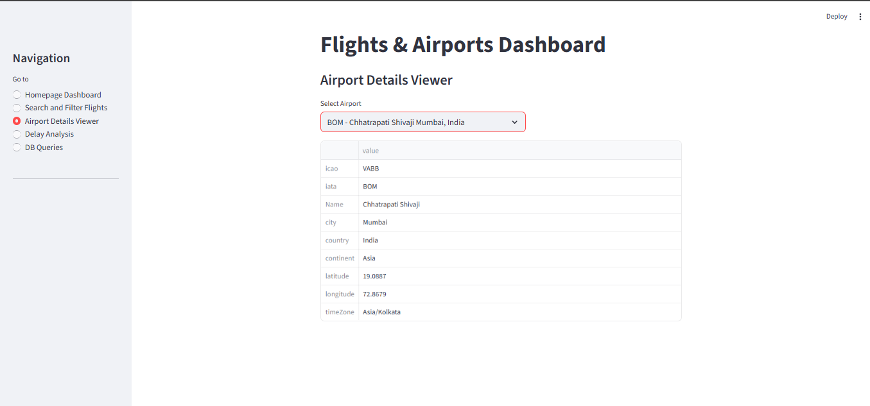
- Delay analysis about arrival and departure flights on a given date
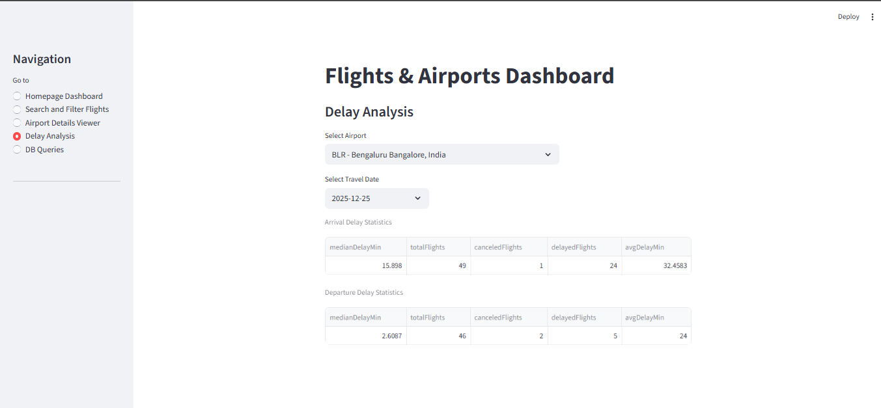

- DB queries, get information of the given queries.
